**Gradient Descent Algorithm**

**(With and without Step Function)**

Max iterations = 10,000

Training Sample = 75

Testing Samples = 75

Learning Rate = 0.02

Initial Weights = [-0.2, -0.1, 0.1, 0.2, 0.3]

**Results:**

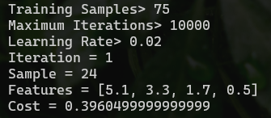

Cost after 1 Iteration = 0.396

Cost after Max Iterations = 0.0028

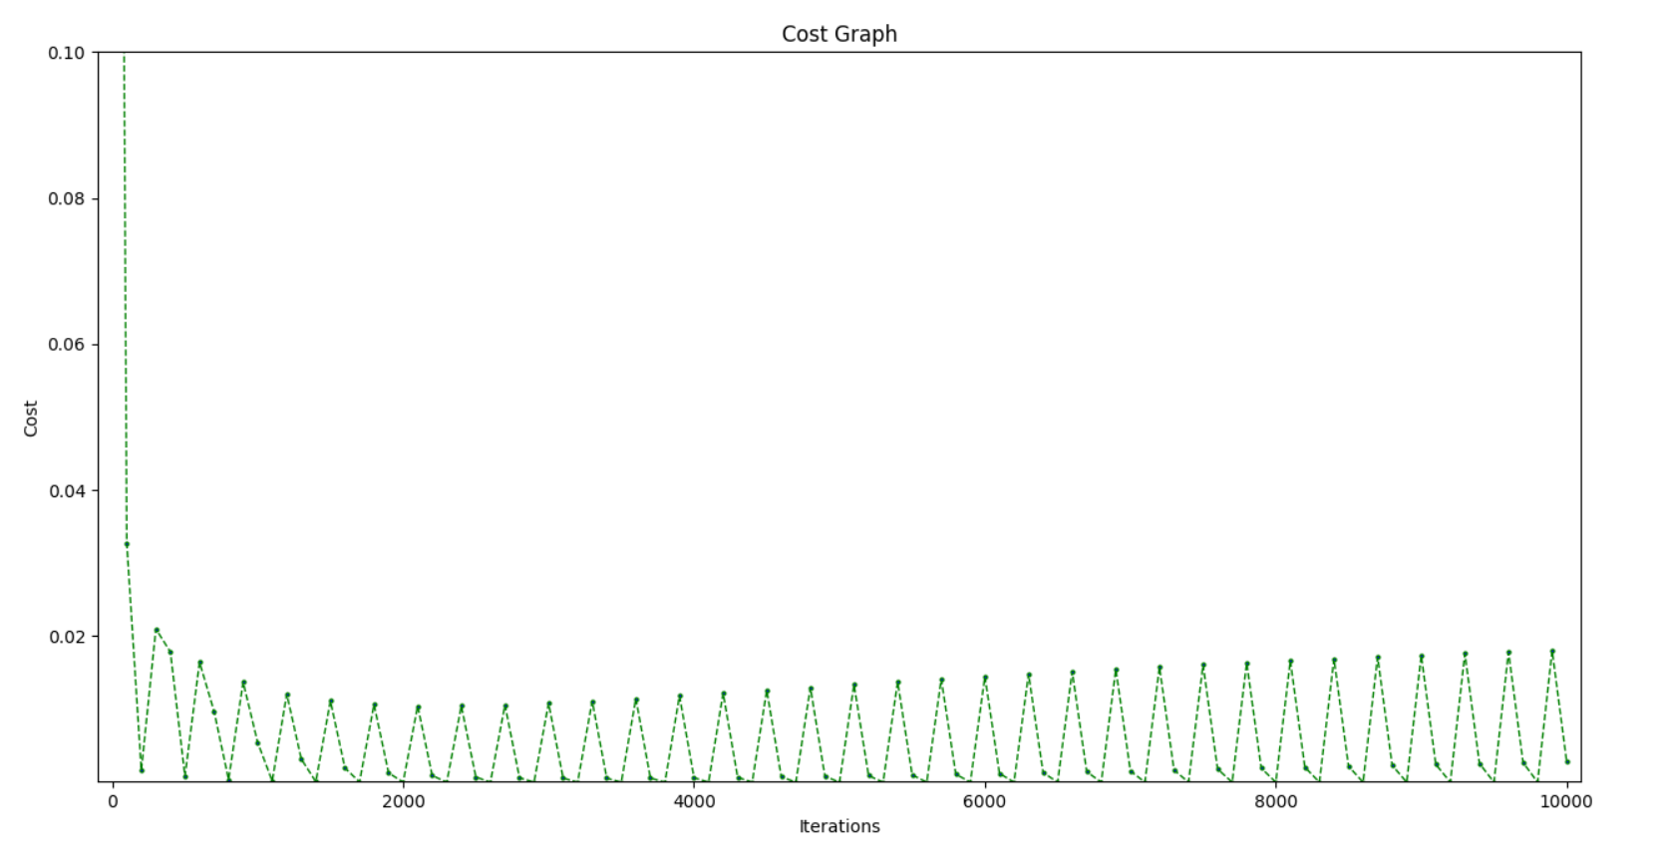



**Testing Phase without Step Function**

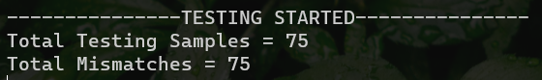

**Problem**

The problem which arises when we don’t use a step function is that we have assigned whole number values to y (actual class label). But when we calculate y_hat (predicted class label), the model returns continuous values.

Now whenever we calculate the difference i.e. y – y_hat, it never matches even if y was 1 and y_hat was 0.9. This is why we have to use Step function to convert y_hat’s value to some whole numbers.

**Testing Phase with Step Function**

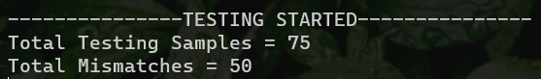

The results did improve as the number of mismatches decreased. But seems like the model’s accuracy is not that good with 75 samples as learning samples.

Accuracy = 33.3 %

**Changing Percentage of Training and Testing Samples**

Max iterations = 10,000

Training Sample = 100

Testing Samples = 50

Learning Rate = 0.02

Initial Weights = [-0.3, 0.2, 0, -0.2, 0.3]

**Training Phase**

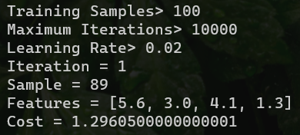

Cost after 1 Iteration = 1.296

Cost after Max Iterations = 0.0142

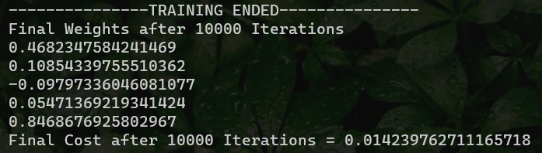

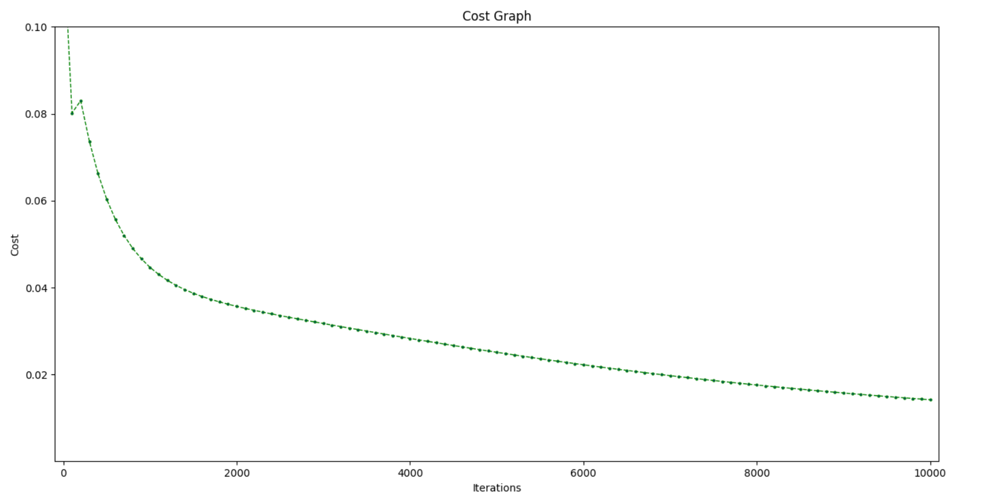

**Testing Phase (without Step Function)**

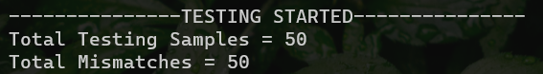

**Problem**

The problem is again the same as before. We have assigned whole number values to y, but the model returns continuous values as y_hat.

**Testing Phase with Step Function**

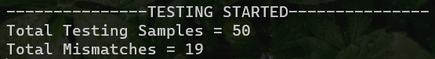

The results did improve as the number of mismatches decreased.

Accuracy = 62 %